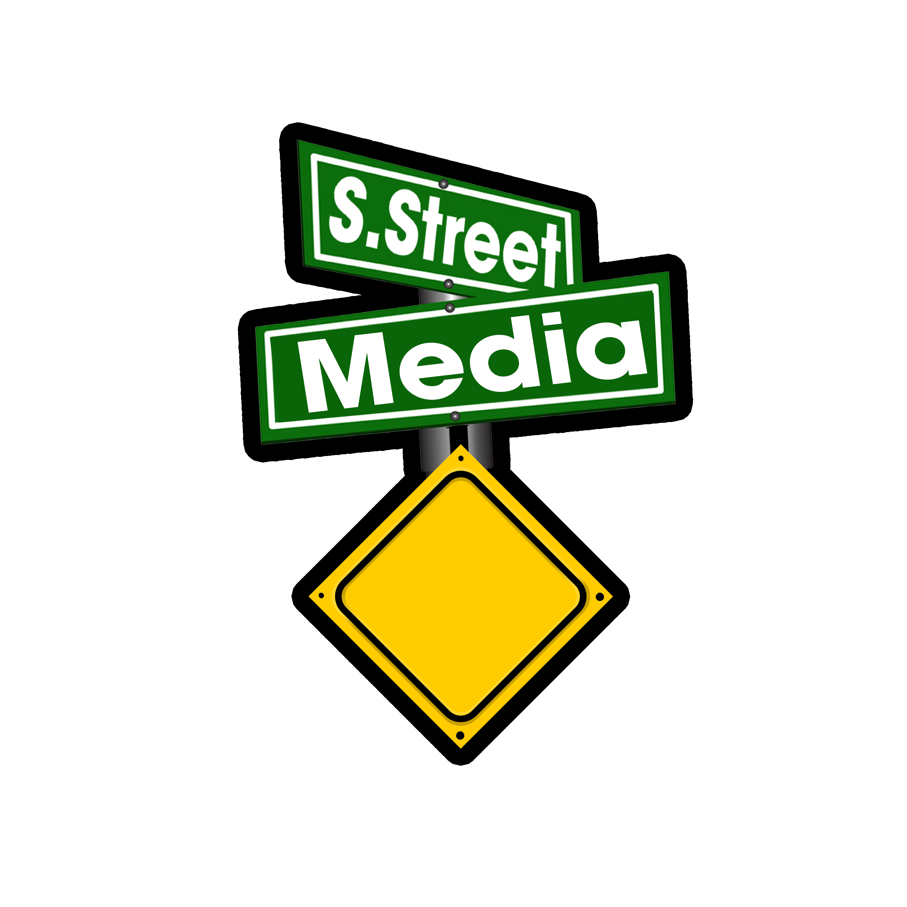
S. Street Media
1639 Centre Street, Ridgewood, NY 11385

Packages for 2019 – 2020
Vendors and Independent Shows

Pod-Casting Fees: $125.00
- Includes (4) four, (1) one hour long episodes.
- Includes audio and visual engineer as well as basic lighting.
- Show will be posted on S. Street Media’s page as well as their YouTube channel.
- Weekly advertisement on S. Street Media’s social network and website.
- Candid pictures will be shot during and after the show.
- Assistance with direction and production concepts.

Rental of Pod-Casting Equipment: $75.00
- Includes the use of equipment for (3) hours.
- Includes access to the facility as well as the audio and visual engineer as well as basic lighting.
- Assistance with direction and production concepts.
- Live streaming is not included with this package.

Venue Rental: $75.00
- Includes (4) hours of renting S. Street Media’s space.
- Equipment is not included; see the “Rental of Equipment” for applicable fees.

Interviews and Music Rotation
- Shows set their own fee schedule for interviews and music rotation.
- S. Street Media has a fee schedule and can send you paid interviews, if needed.

